Introduction

Well… this is an introduction! =)

# What is Digital Image Processing?

Image is a function: **f(x, y)**

The **amplitude** of **f** at any point is called **intensity** or **gray level**.

If values of x, y (spatial coordinates) and f are finite and discrete, we have a **digital image**.

**Pixel**: a single element of a digital image

There are other areas related to *image processing*, like *image analysis* and *computer vision*.

**Image processing:** Image preprocessing, noise reduction, contrast enhancement, image sharpening (Low-level of processing, usually, input and output are images)

**Image Analysis:** Segmentation, description of the resulting objects, and classification of individual objects. (Mid-level of processing, usually, input is an image and output is an attribute of those image)

**Computer vision:** Perform cognitive functions associated with human vision. (Higher level processing)

# The origin of Digital Image Processing

Well, this is a brief history about image processing, maybe, in the future, I write about this

…

…

…

# Examples of Fields That use Digital Image Processing

## Gamma-Ray Imaging

### Nuclear medicine

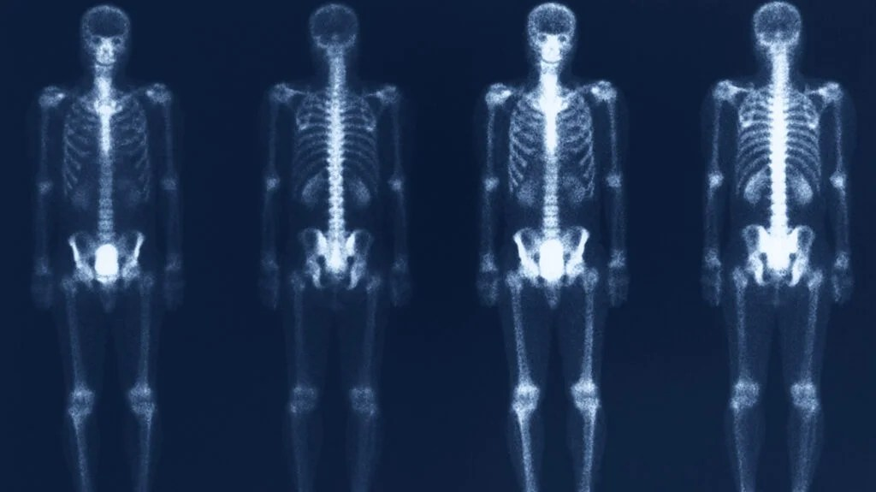Bone Scan obtained using Gamma-Ray imaging

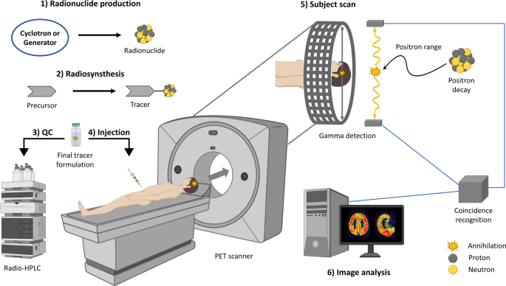Positron emission tomography (PET)

### Astronomical observations

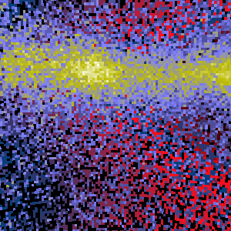

Cygnus Loop

## X-Ray Imaging

### Medical

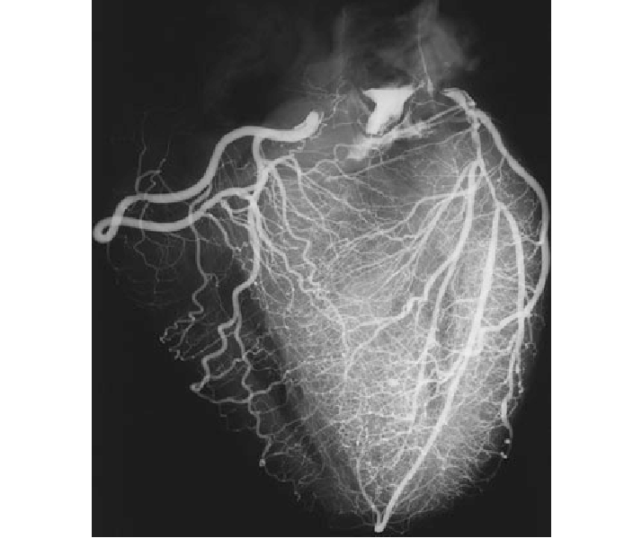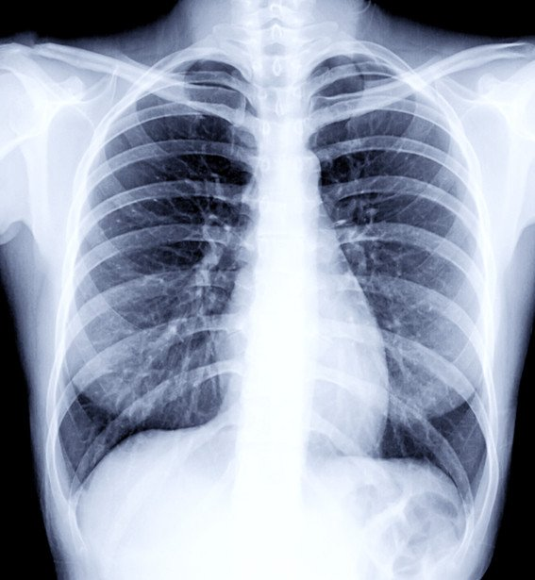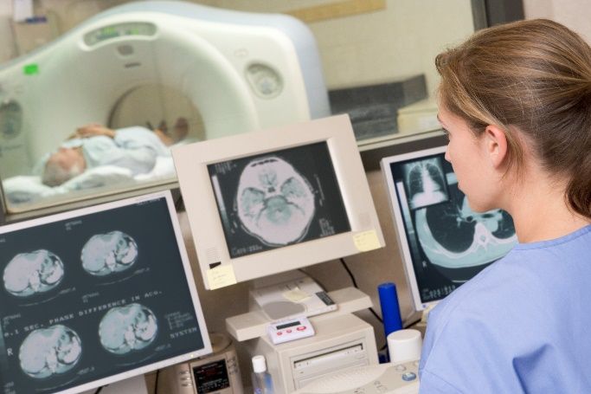

Angiography Chest X-ray Computerized axial tomography (CAT)

### Industrial

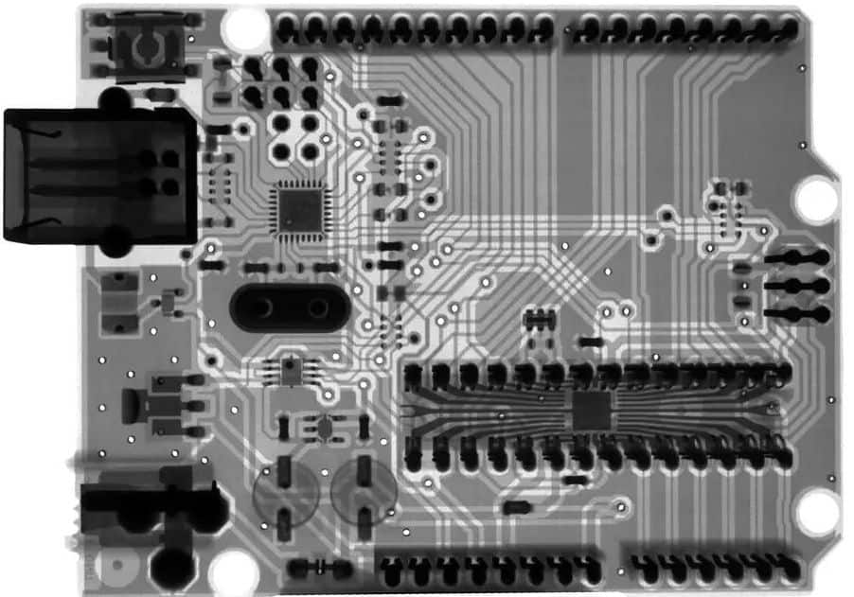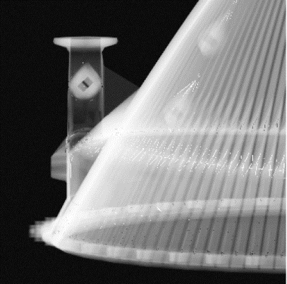

Circuit Board Rocket Engine

### Astronomical

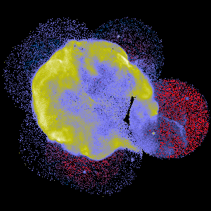

Cygnus Loop

## Imaging in the Ultraviolet Band

### Microscopy

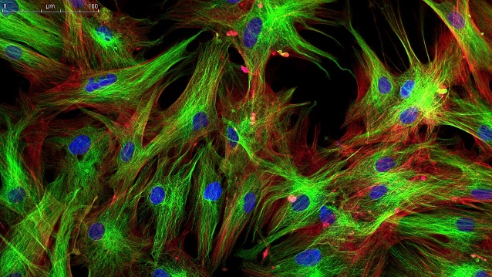

Fluorescence microscopy image

### Astronomical

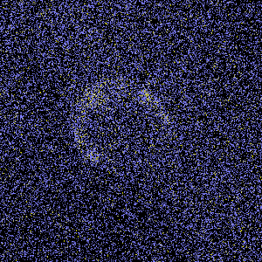

Cygnus loop

## Visible and infrared bands

I’ll do it later because lazyyy :o

…

…

…

## Imaging in the microwave band

Radar (due to its ability to collect data over any region, regardless of weather or lighting conditions)

Some waves can see through clouds, vegetation, ice or even dry sand

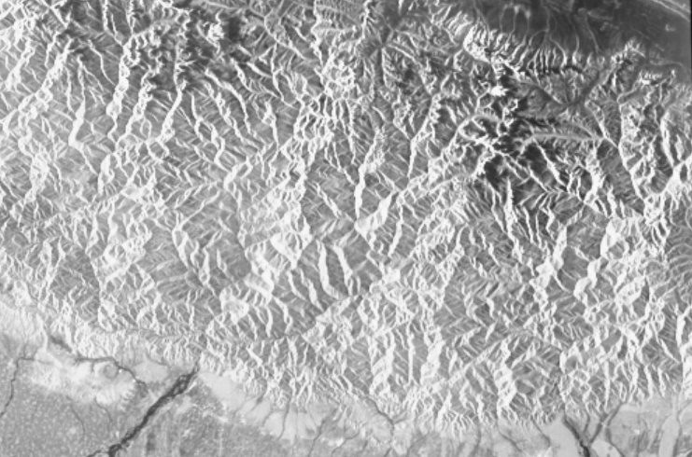

Himalaya

## Imaging in the radio band

### Medicine

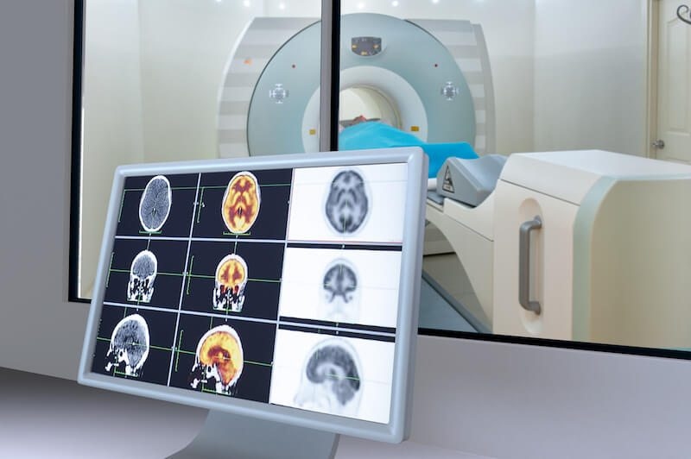

Magnetic resonance imaging

### Astronomy

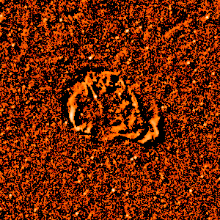

Cygnus Loop

## Other imaging modalities